Building a Campus Study Assistant with Amazon Bedrock (Part 3: Interactive Web UI with Streamlit & File Uploads)

In Part 1, we set up our AWS environment and connected to Bedrock. In Part 2, we built a script to extract from both .pdf and .docx coursework file.
Now in Part3, we will turn that terminal script into a web app. Instead of opening VS Code and editing file paths, you will be able to upload files in your browser and view structured study guides instantly.

Step 1: Install Streamlit
- Streamlit is a python framework that lets you build web interfaces for data and AI applications without writing HTML, CSS, or Javascript.
- Run this in the terminal: pip install streamlit.

Step 2: Create a new file inside your folder
- Name the file: app.py

Step 3: Code
- The code as below:
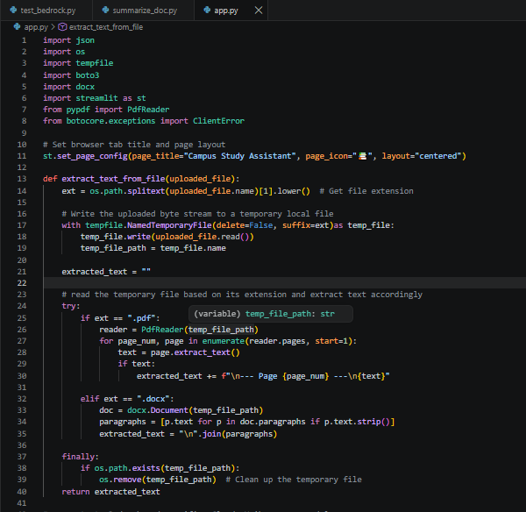

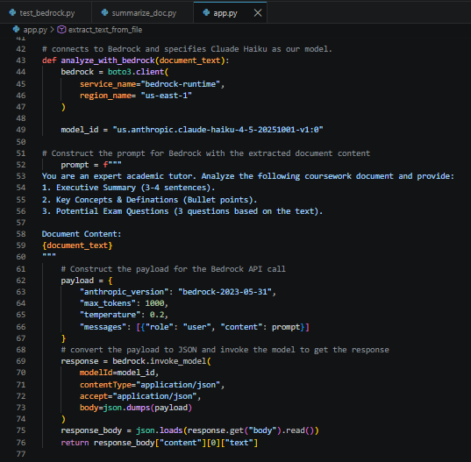

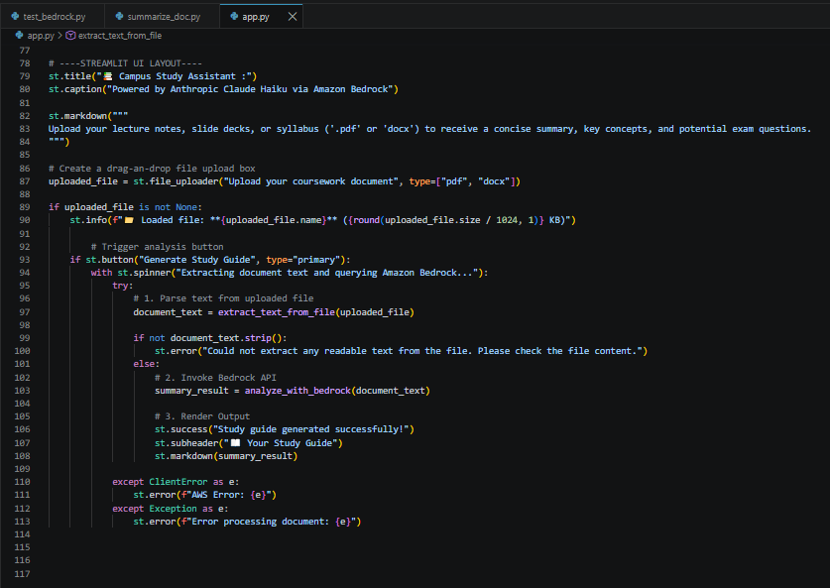
- The Streamlit UI flow:
[Browser] ───> st.file_uploader() ───> Drop PDF/Word File
│
▼
st.button("Generate Study Guide") ───> (Clicked)
│
▼
st.spinner() (Loading Animation)
│
├──> 1. extract_text_from_file()
└──> 2. analyze_with_bedrock()
│
▼
st.markdown() ───> Formatted Study Guide appears on screen

Step 4: run the code
- Run this in the terminal: streamlit run app.py
- Login Page:

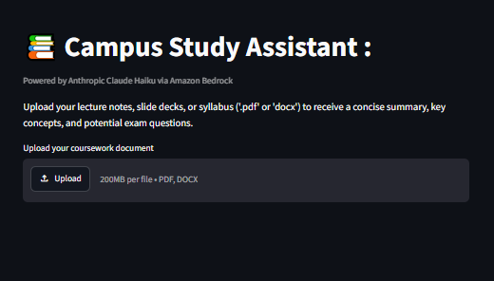

- After uploading your notes
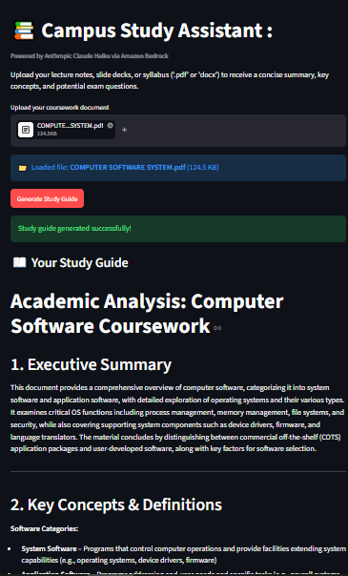

💡 Challenge & Solution: From Single-File to Multi file acceptance
- The Challenge: Streamlit’s default uploader only allowed one document at a time. Processing multiple files individually generated fragmented summaries and triggered separate AWS calls, driving up latency and API costs.
- The Solution: We set “accept_multiple_files=True” in Streamlit and modified our backend to combine all document text locally before calling Amazon Bedrock.
- The Result: Claude Haiku receives the full coursework context in a single API call, generating one cohesive Master Study Guide while keeping latency and AWS costs minimal.

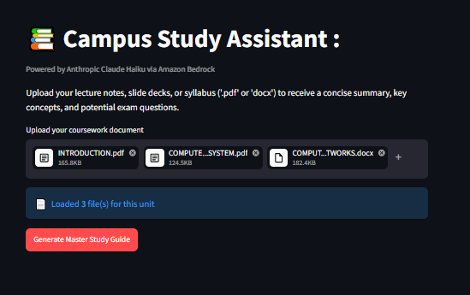

With this application running locally on your machine, you can drop in entire semesters of lecture slides, syllabi, or reading notes and get concise summaries, key definitions, and exam prep questions within seconds—all powered by AWS Bedrock and Claude Haiku.

